**PRACTICAL NO: 1**

**AIM:** Write a program to implement insertion sort and find the running time of the memory complexity.

PROGRAM CODE:

package insertion;

import java.util.Scanner;

public class Insertion {

public static void main(String[] args) {

System.out.println("Enter number of inputs in array:");

Scanner a=new Scanner(System.in);

int n=a.nextInt();

int b[] = new int[n];

System.out.println("Enter all elements:");

for(int i=0;i<n;i++){

b[i] = a.nextInt();

}

System.out.println("\n");

insertionSort(b);

}

private static void printNumbers(int[] input){

for(int i=0;i<input.length;i++){

System.out.println(input[i]+",");

}

System.out.println("\n");

}

private static void insertionSort(int[] array) {

int n=array.length;

for(int j=1;j<n;j++){

int key=array[j];

int i=j-1;

while((i>-1) && (array[i]>key)){

array[i+1]=array[i];

i--;

}

array[i+1]=key;

printNumbers(array);

}

double time=n*(n-1)/2;

System.out.println("Running Time: "+time+" units");

}

}

**OUTPUT:**

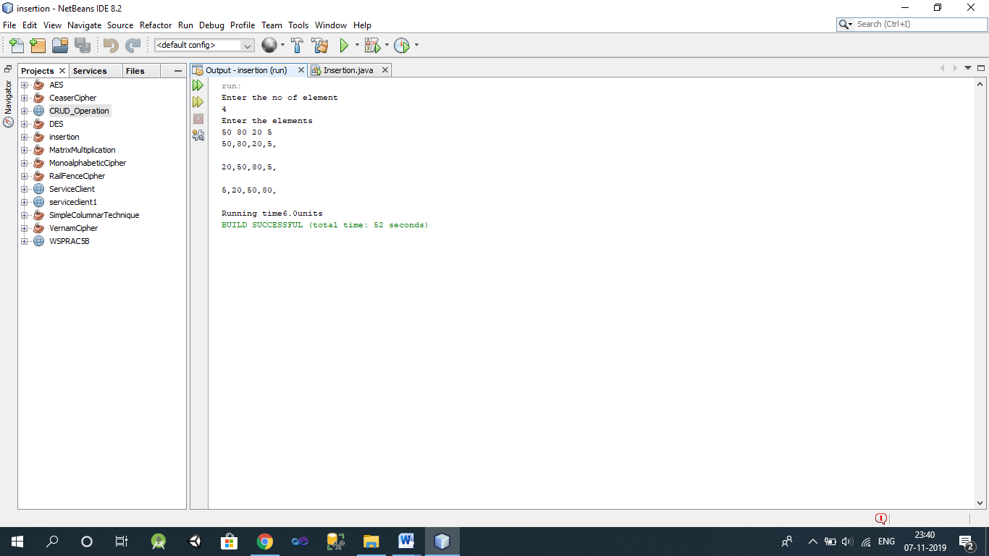

**PRACTICAL NO: 2**

**AIM:** Write a program to implement merge sort algorithm. Compare the time and memory complexity.

PROGRAM CODE:

package mergesort;

import java.util.Scanner;

public class MergeSort

{

public static void sort(int[] a, int low, int high){

int N = high - low;

if (N <= 1)

return;

int mid = low + N/2;

sort(a, low, mid);

sort(a, mid, high);

int[] temp = new int[N];

int i = low, j = mid;

for (int k = 0; k<N; k++){

if (i == mid)

temp[k] = a[j++];

else if (j == high)

temp[k] = a[i++];

else if (a[j]<a[i])

temp[k] = a[j++];

else

temp[k] = a[i++];

}

for (int k = 0; k<N; k++)

a[low + k] = temp[k];

}

public static void main(String[] args) {

Scanner scan = new Scanner( System.in );

System.out.println("Merge Sort Test\n");

int n, i;

System.out.println("Enter number of integer elements:-");

n = scan.nextInt();

int arr[] = new int[ n ];

System.out.println("\nEnter &quot;+ n +&quot; integer elements:-");

for (i = 0; i<n; i++)

arr[i] = scan.nextInt();

sort(arr, 0, n);

System.out.println("\nElements after sorting:-");

for (i = 0; i<n; i++)

System.out.print(arr[i]+"");

System.out.println();

}

}

**Output:-**

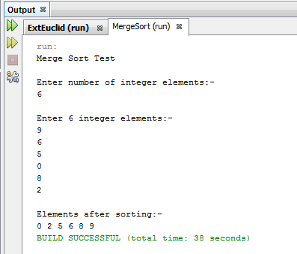

**PRACTICAL NO: 3**

**AIM:** Write a program to implement Longest Common Subsequence(LCS) algorithm.

PROGRAM CODE:

package lcs;

import java.io.BufferedReader;

import java.io.IOException;

import java.io.InputStreamReader;

public class LCS

{

int count=0;

public String lcs(String str1, String str2){

int l1 = str1.length();

int l2 = str2.length();

int[][] arr = new int[l1 + 1][l2 + 1];

for (int i = l1 - 1; i >= 0; i--){

for (int j = l2 - 1; j >= 0; j--){

if (str1.charAt(i) == str2.charAt(j))

arr[i][j] = arr[i + 1][j + 1] + 1;

else

arr[i][j] = Math.max(arr[i + 1][j], arr[i][j + 1]);

}

}

int i = 0, j = 0;

StringBuffer sb = new StringBuffer();

while (i < l1 && j < l2){

if (str1.charAt(i) == str2.charAt(j)){

sb.append(str1.charAt(i));

i++;

j++;

count++;

}

else if (arr[i + 1][j] >= arr[i][j + 1])

i++;

else

j++;

}

return sb.toString();

}

public static void main(String[] args) throws IOException

{

BufferedReader br = new BufferedReader(new InputStreamReader(System.in));

System.out.println("Longest Common Subsequence Algorithm Test\n");

System.out.println("\nEnter string 1");

String str1 = br.readLine();

System.out.println("\nEnter string 2");

String str2 = br.readLine();

LCS obj = new LCS();

String result = obj.lcs(str1, str2);

System.out.println("\nLongest Common Subsequence : "+ result);

System.out.println("\nLength Of Longest Common Subsequence : "+obj.count);

}

}

**Output:-**

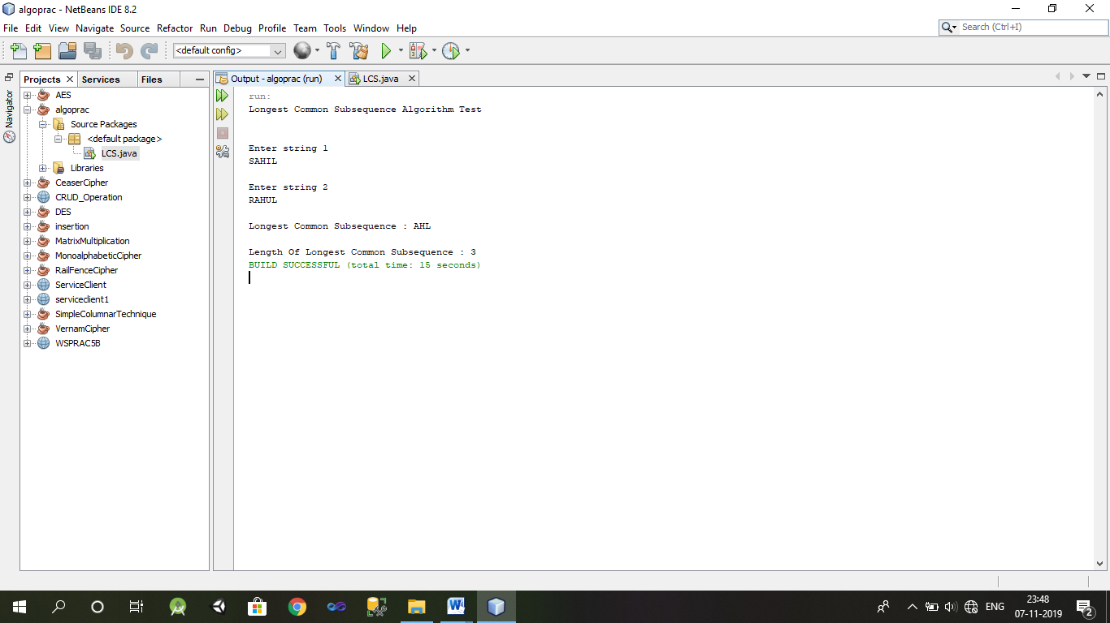

**PRACTICAL NO;4**

**AIM:** Write a program to implement Euclid’s algorithm to implement gcd of two non negative integers a and b. Extend the algorithm to find x and y such that gcd(a,b) = ax+by. Compare the running time and recursive calls made in each case.

PROGRAM CODE:

package exteuclid;

import java.io.BufferedReader;

import java.io.IOException;

import java.io.InputStreamReader;

public class ExtEuclid {

public static void main(String[] args) throws IOException {

int [] ans = new int[3];

int x,y,a,b;

BufferedReader br = new BufferedReader (new InputStreamReader(System.in));

System.out.println("Enter the first non negative number :");

a=Integer.parseInt(br.readLine());

System.out.println("Enter the second non negative number:");

b=Integer.parseInt(br.readLine());

ans=Euclid(a,b);

System.out.println("GCD of" +a+ "and" +b+ ";");

System.out.println("\n gcd ("+a+","+b+")="+ans[0]+"\n");

System.out.println("Extended form :\n");

System.out.println(" d="+ans[0]+" s="+ans[1]+" t="+ans[2]+"");

}

public static int[]Euclid(int a, int b)

{

int[]ans=new int[3];

int q;

if(b==0)

{

ans[0]=a;

ans[1]=1;

ans[2]=0;

}

else{

q=a/b;

ans=Euclid(b,a%b);

int temp=ans[1]-ans[2]*q;

ans[1]=ans[2];

ans[2]=temp;

}

return ans;

}

}

**OUTPUT:**

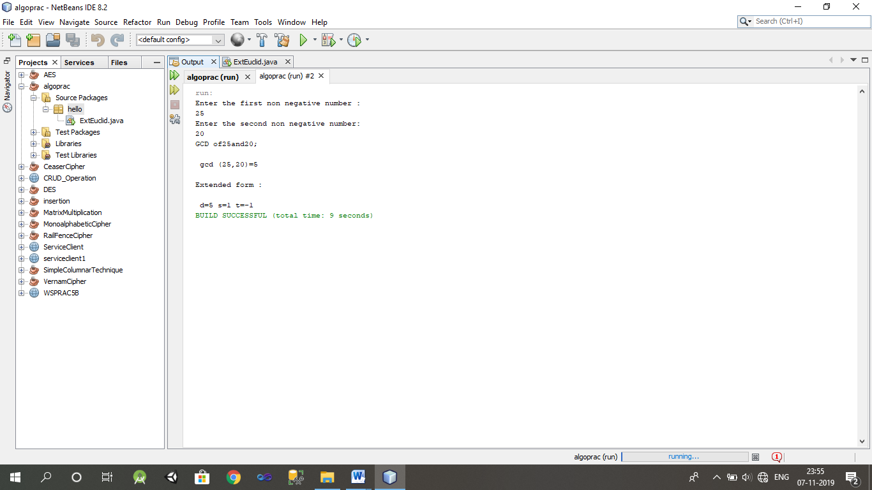

**PRACTICAL NO: 5**

**AIM:** Write a program to implement Huffman’s code algorithm.

PROGRAM CODE:

package huffman;

import java.util.*;

import java.io.*;

abstract class HuffmanTree implements Comparable<HuffmanTree> {

public final int frequency;

public HuffmanTree(int freq) {

frequency = freq;

}

public int compareTo(HuffmanTree tree) {

return frequency - tree.frequency;

}

}

class HuffmanLeaf extends HuffmanTree {

public final char value;

public HuffmanLeaf(int freq, char val) {

super(freq);

value = val;

}

}

class HuffmanNode extends HuffmanTree {

public final HuffmanTree left, right;

public HuffmanNode(HuffmanTree l, HuffmanTree r) {

super(l.frequency + r.frequency);

left = l;

right = r;

}

}

public class Huffman {

public static HuffmanTree buildTree(int[] charFreqs, char[] test2) {

PriorityQueue<HuffmanTree> trees = new PriorityQueue<HuffmanTree>();

for (int i = 0; i < charFreqs.length;i++)

if (charFreqs[i] > 0) {

trees.offer(new HuffmanLeaf(charFreqs[i], test2[i]));

}

assert trees.size() > 0;

while (trees.size() > 1) {

HuffmanTree a = trees.poll();

HuffmanTree b = trees.poll();

trees.offer(new HuffmanNode(a, b));

}

return trees.poll();

}

public static void printCodes(HuffmanTree tree, StringBuffer prefix) {

assert tree != null;

if (tree instanceof HuffmanLeaf) {

HuffmanLeaf leaf = (HuffmanLeaf) tree;

System.out.println(leaf.value + "\t" + leaf.frequency + "\t" + prefix);

} else if (tree instanceof HuffmanNode) {

HuffmanNode node = (HuffmanNode) tree;

prefix.append("0");

printCodes(node.left, prefix);

prefix.deleteCharAt(prefix.length() - 1);

prefix.append("1");

printCodes(node.right, prefix);

prefix.deleteCharAt(prefix.length() - 1);

}

}

public static void main(String[] args){

Scanner s = new Scanner(System.in);

System.out.println("Enter 6 elements for the array");

String str = "abcdef";

int n = 6;

char[] test2 = str.toCharArray();

int charFreqs[] = new int[n];

for(int i = 0; i < n; i++)

{

charFreqs[i] = s.nextInt();

}

HuffmanTree tree = buildTree(charFreqs, test2);

System.out.println("SYMBOL\tFREQ\tHUFFMAN CODE");

printCodes(tree, new StringBuffer()); }

}

**OUTPUT:-**

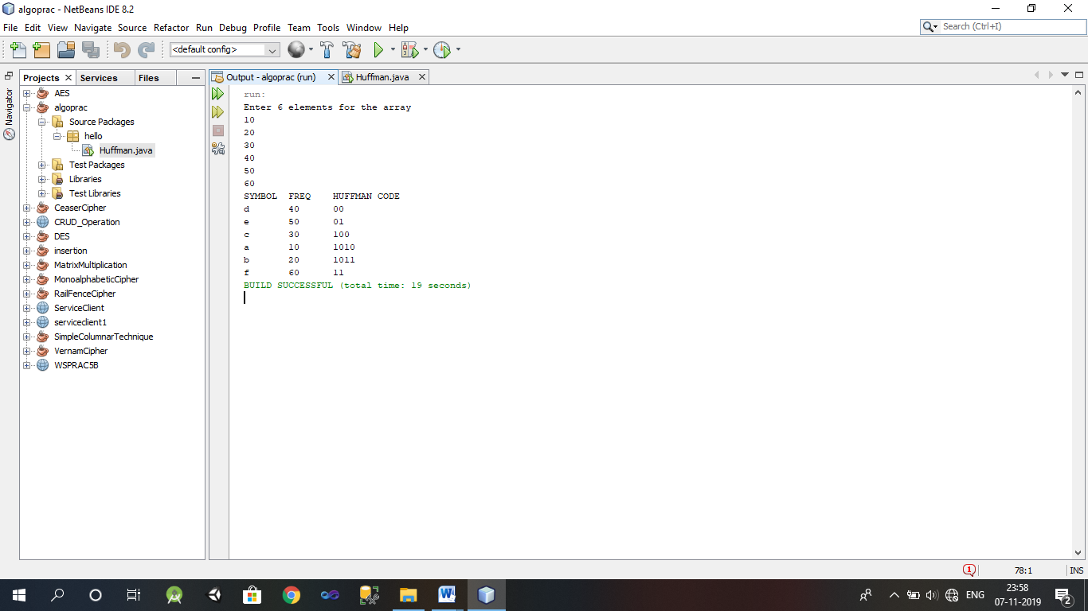

**PRACTICAL NO: 6**

**AIM:** Write a program to implement Kruskal’s algorithm.

PROGRAM CODE:

package krushkal;

import java.util.*;

public class Krushkal

{

public final static Scanner STDIN_SCANNER = new Scanner(System.in);

public static int i,j,k,a,b,u,v,n,ne=1;

public static int min,mincost=0;

public static int[][]cost = new int[20][20];

public static int[] parent = new int[20];

public static void main(String[] args)

{

System.out.println("\n\t implementation of krushkal's algorithm");

System.out.println("\n Enter the no. of vertices:");

n=STDIN_SCANNER.nextInt();

System.out.println("\n Enter the cost adjacency matrix:");

for(i=1;i<=n;i++)

{

for(j=1;j<=n;j++)

{

cost[i][j]=STDIN_SCANNER.nextInt();

if(cost[i][j]==0)

{

cost[i][j]=999;

}

}

}

System.out.println("the edges of minimum cost spanning tree are");

while(ne<n)

{

min = 999;

for(i=1;i<=n;i++)

{

for(j=1;j<=n;j++)

{

if(cost[i][j]<min)

{

min = cost[i][j];

a=u=i;

b=v=j;

}

}

}

if(v!=u)

{

parent[v]=u;

ne++;

System.out.println("edge("+a+","+b+")="+ min);

mincost+=min;

}

cost[a][b] = (cost[b][a] = 999);

}

System.out.println("\n\t minimum cost=" +mincost);

}

}

**OUTPUT:**

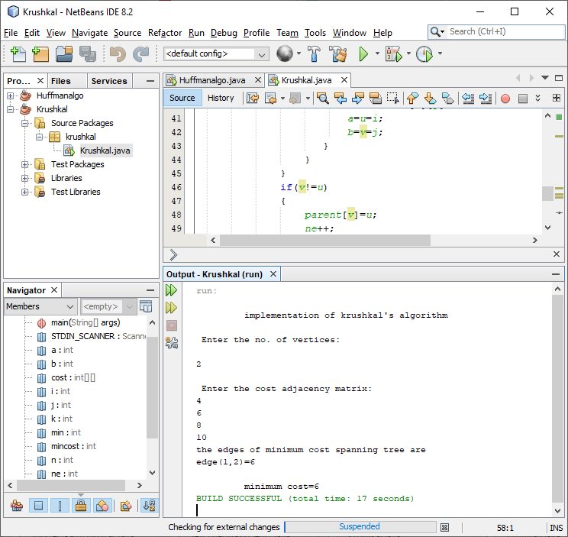

**PRACTICAL NO: 7**

**AIM:** Write a program to Implement Dijkstra’s Algorithm.

PROGRAM CODE:

package hello;

import java.util.*;

import java.lang.*;

import java.io.*;

public class ShortestPathDijkstras

{

static int V=5;

int minDistance(int dist[],Boolean sptSet[])

{

int min=Integer.MAX_VALUE,min_index=-1;

for(int v=0;v<V;v++)

if(sptSet[v]==false && dist[v]<=min)

{

min= dist[v];

min_index=v;

}

return min_index;

}

void printSolution(int dist[],int n)

{

System.out.println("Vertex\t\tDistance from Source");

for(int i=0;i<V;i++)

System.out.println(i+"\t\t\t"+dist[i]);

}

void dijkstra(int graph[][],int src)

{

int dist[]=new int[V];

Boolean sptSet[]=new Boolean[V];

for(int i=0;i<V;i++)

{

dist[i]=Integer.MAX_VALUE;

sptSet[i]=false;

}

dist[src]=0;

for(int count=0;count<V-1;count++)

{

int u=minDistance(dist,sptSet);

sptSet[u]=true;

for(int v=0;v<V;v++)

{

if(!sptSet[v]&& graph[u][v]!=0

&&dist[u]!=Integer.MAX_VALUE&&dist[u]+graph[u][v]<dist[v])

{

dist[v]=dist[u]+graph[u][v];

}

}

printSolution(dist,V);

}

}

public static void main(String[]args)

{

Scanner scan=new Scanner(System.in);

int vertices;

int[][] graph;

System.out.println("####### Dijktras Algorithm #######");

V=scan.nextInt();

graph=new int[V][V];

System.out.println("Enter the distance of each vertex:");

for (int i=0;i<V;i++)

{

for(int j=0;j<V;j++)

{

graph[i][j]=scan.nextInt();

}

}

ShortestPathDijkstras obj1=new ShortestPathDijkstras();

obj1.dijkstra(graph, 0);

}

}

**OUTPUT:-**

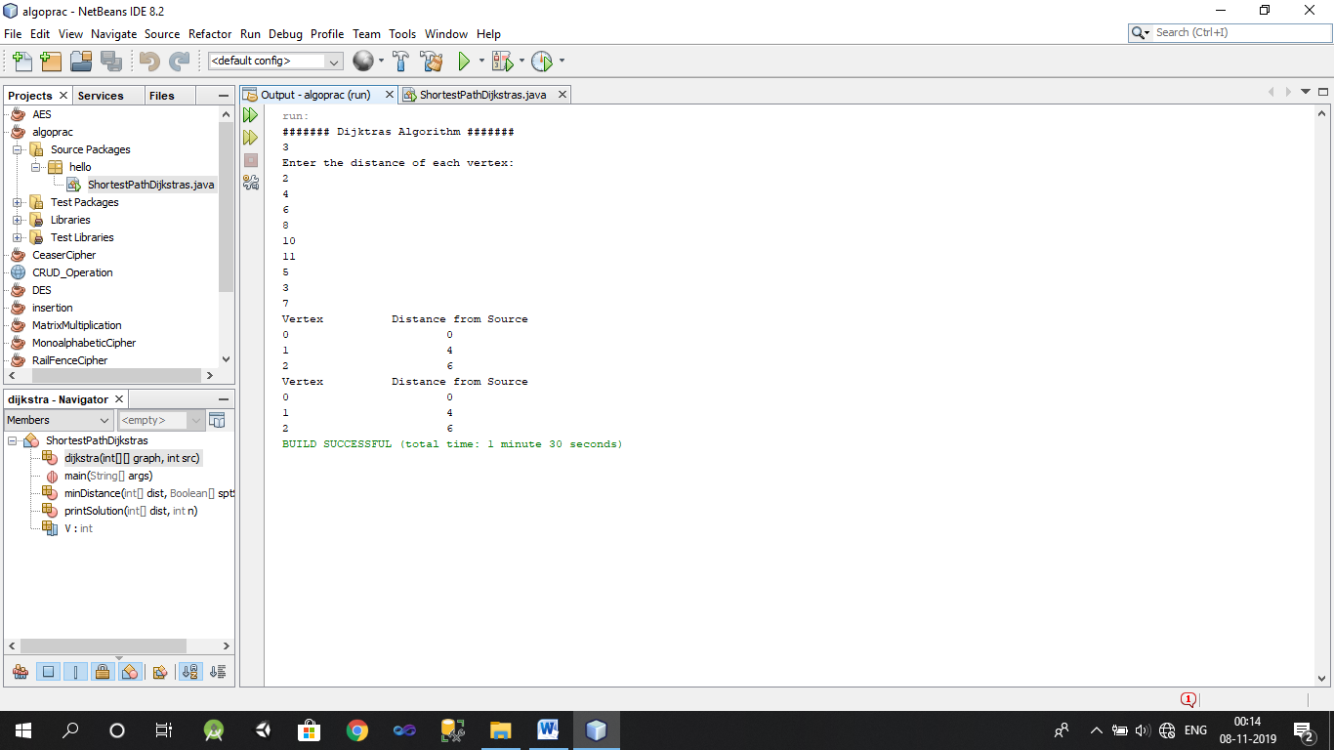

**PRACTICAL NO: 8**

**AIM:** Write a program to implement greedy set cover algorithm to solve set covering problem.

PROGRAM CODE:

package practicalno8;

import java.util.ArrayList;

import java.util.Arrays;

import java.util.Collections;

import java.util.Comparator;

import java.util.LinkedHashSet;

import java.util.List;

import java.util.Scanner;

import java.util.Set;

public class Practicalno8

{

interface Filter<T>

{

boolean matches(T t);

}

private static <T> Set<T> shortestCombination(Filter<Set<T>> filter,List<T> listOfSets)

{

final int size = listOfSets.size();

if (size > 20)

throw new IllegalArgumentException("Too many combinations");

int combinations = 1 << size;

List<Set<T>> possibleSolutions = new ArrayList<Set<T>>();

for (int l = 0; l < combinations; l++)

{

Set<T> combination = new LinkedHashSet<T>();

for (int j = 0; j < size; j++)

{

if (((l >> j) & 1) != 0)

combination.add(listOfSets.get(j));

}

possibleSolutions.add(combination);

}

Collections.sort(possibleSolutions, new Comparator<Set<T>>()

{

public int compare(Set<T> o1, Set<T> o2)

{

return o1.size() - o2.size();

}

}

);

for (Set<T> possibleSolution : possibleSolutions)

{

if (filter.matches(possibleSolution))

return possibleSolution;

}

return null;

}

public static void main(String[] args){

System.out.println("Enter 2D array size : ");

Scanner sc=new Scanner(System.in);

System.out.println("Enter rows size of array : ");

int rows=sc.nextInt();

System.out.println("Enter columns size of array : ");

int columns=sc.nextInt();

System.out.println("Enter array elements : ");

Integer arrayOfSets[][]=new Integer[rows][columns];

for(int i=0; i<rows;i++)

{

for(int j=0; j<columns;j++)

{

arrayOfSets[i][j]=sc.nextInt();

}

}

Integer[] solution = { 1, 2, 3, 4, 5, 6, 7, 8, 9, 10 };

List<Set<Integer>> listOfSets = new ArrayList<Set<Integer>>();

for (Integer[] array : arrayOfSets)listOfSets.add(new LinkedHashSet<Integer>(Arrays.asList(array)));

final Set<Integer> solutionSet = new LinkedHashSet<Integer>(Arrays.asList(solution));

Filter<Set<Set<Integer>>> filter = new Filter<Set<Set<Integer>>>()

{

public boolean matches(Set<Set<Integer>> integers)

{

Set<Integer> union = new LinkedHashSet<Integer>();

for (Set<Integer> ints : integers)

union.addAll(ints);

return union.equals(solutionSet);

}

};

Set<Set<Integer>> firstSolution = shortestCombination(filter,listOfSets);

System.out.println("The shortest combination was " + firstSolution);

}

}

**OUTPUT:**

